26.81: a) If the given capacitor was fully charged for the given emf, 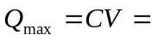
Since it has more charge than this after it was connected, this tells us the capacitor is discharging and so the current must be flowing toward the negative plate. The capacitor started with more charge than was “allowed” for the given emf. Let
b) As time goes on, the capacitor will discharge to 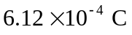 as calculated above.

